SIMATS ENGINEERING

ASSESSMENT TOOL 1

COURSE NAME: Database Management Systems COURSE CODE: CSA05

COURSE OUTCOME COVERED

CO1: Analyze DBMS architecture, different data models, schema types, and design ER/EER diagrams, relational schemas for case-based scenarios by identifying entities and relationships. (BL1, BL2)

Activity Tool : Short Answer Text(High) Assessment Tool Weightage: 30%

Dr

QUESTIONS |  | Total Marks: 50
Q.No | Question | Bloom's Level | Marks
1 | UPS Product Tracking Information System | BL1 – | 5
 |  | Remember
 | UPS prides itself on having up-to-date information on the processing and current location of each shipped item. To do this, UPS relies on a company-wide information system. Shipped items are the heart of the UPS product tracking information system. Shipped items can be characterized by item number (unique), weight, dimensions, insurance amount, destination, and final delivery date. Shipped items are received into the UPS system at a single retail center. Retail centers are characterized by their type, uniqueID, and address. Shipped items make their way to their destination via one or more standard UPS transportation events (i.e., flights, truck deliveries). These transportation events are characterized by a unique scheduleNumber, a type (e.g, flight, truck), and a deliveryRoute. Create an Entity Relationship diagram that captures this

 | information about the UPS system.
2 | Course Management System  Consider a university database for the scheduling of classrooms for final exams. This database could be modeled as the single entity set exam, with attributes course-name, section-number, room-number, and time. Alternatively, one or more additional entity sets could be defined, along with relationship sets to replace some of the attributes of the exam entity set, as  - course with attributes name, department, and c-number  - section with attributes s-number and enrollment, and dependent as a weak entity set on course  - room with attributes r-number, capacity, and building Show an E-R diagram illustrating the use of all three additional entity sets listed. | BL2 –  Understand | 5
3 | University Registrar’s Office Management System  A university registrar’s office maintains data about the following entities:  - courses, including number, title, credits, syllabus, and prerequisites;  - course offerings, including course number, year, semester, section number, instructor(s), timings, and classroom;  - students, including student-id, name, and program;  - instructors, including identification number, name, department, and title.  - Further, the enrollment of students in courses and grades awarded to students in each course they are enrolled for must be appropriately modeled.  Construct an E-R diagram for the registrar’s  office. | BL2 –  Understand | 5
4 | Hospital Management System  Construct an E-R diagram for a hospital with a set of patients and a set of medical doctors.  Associate with each patient a log of the various tests | BL2 –  Understand | 5

and examinations conducted. Construct appropriate tables for the above ER Diagram :
Patient(SS#, name, insurance) Physician ( name, specialization) Test-log( SS#, test-name, date, time) Doctor-patient (physician-name, SS#) Patient-history(SS#, test-name, date)
5 | Company Project Management System  Construct an ER Diagram for Company having following details :  Company organized into DEPARTMENT. Each department has unique name and a particular employee who manages the department. Start date for the manager is recorded. Department may have several locations.  A department controls a number of PROJECT. Projects have a unique name, number and a single location.  Company’s EMPLOYEE name, ssno, address, salary, sex and birth date are recorded. An employee is assigned to one department, but may work for several projects (not necessarily controlled by dept). Number of hours/week an employee works on each project is recorded; The immediate supervisor for the employee.  Employee’s DEPENDENT are tracked for health insurance purposes (dependentname, birthdate, relationship to employee). | BL2 –  Understand | 5
6 | Explain schema and instance with examples. Distinguish between logical schema, physical schema, and view schema. | BL1 –  Remember | 5
7 | Identify the entities, attributes, and relationships for a Bank Management System and construct its ER diagram. | BL2 –  Understand | 5
8 | Explain the Extended ER (EER) model. Describe the concepts of generalization, specialization, and aggregation. | BL2 –  Understand | 5
9 | Design an EER diagram for a Hospital Management | BL2 – | 5

 | System incorporating inheritance and weak entities. | Understand
10 | Explain the role of a DBA (Database Administrator) and the responsibilities associated with the position. | BL1 –  Remember | 5

Code of Conduct:

I Jenitha Jothi J 192520013 (Name / Reg No) certify that this submission is my original work and that I have adhered to the guidelines specified for this assessment. I understand that any violation of academic integrity rules will result in disciplinary action.

Signature of the student:

RUBRICS FOR CALCULATION:

Criteria | Weightage | Level 4 (Exemplary) | Level 3 (Proficient) | Level 2 (Developing) | Level 1 (Beginning)
Concept Identification | 30% | Demonstrates clear and complete understanding of the concept | Good understanding with minor gaps | Basic understanding with some misconceptions | Poor or incorrect understandin g
Linkages | 25% | Completely correct answer with no errors | Mostly correct with minor errors | Partially correct with noticeable errors | Incorrect or irrelevant answer
Organization | 20% | Correctly applies concepts to solve  the question/problem | Applies concepts with minor mistakes | Limited or partially correct application | No or incorrect application
Integration of Literature | 15% | Covers all required parts of the question | Covers most parts with minor omissions | Covers only some parts | Incomplete or missing response
Clarity | 10% | Clear, concise, and well- | Understandabl e with minor | Somewhat unclear or | Difficult to understand

 |  | organized answer | issues | poorly structured

1.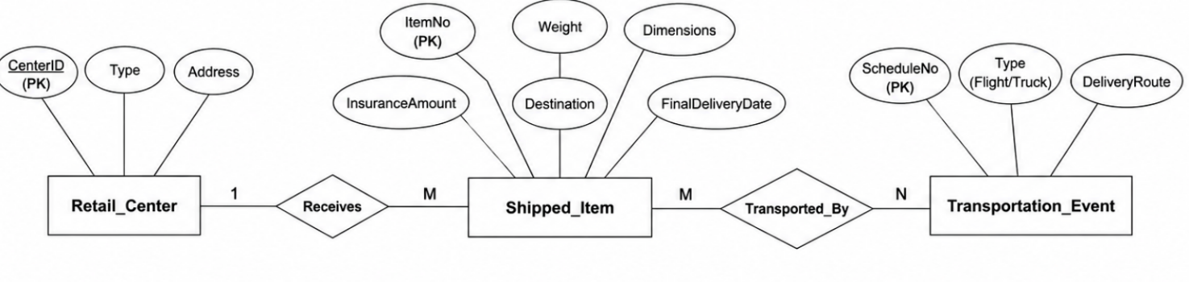
2.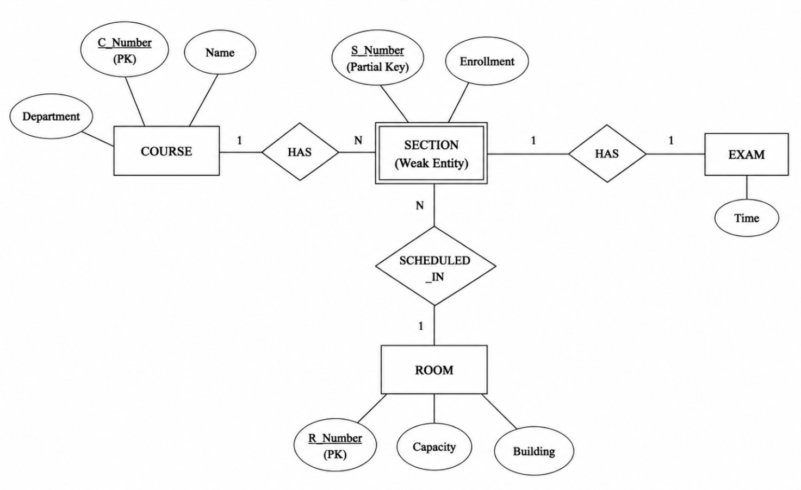

3.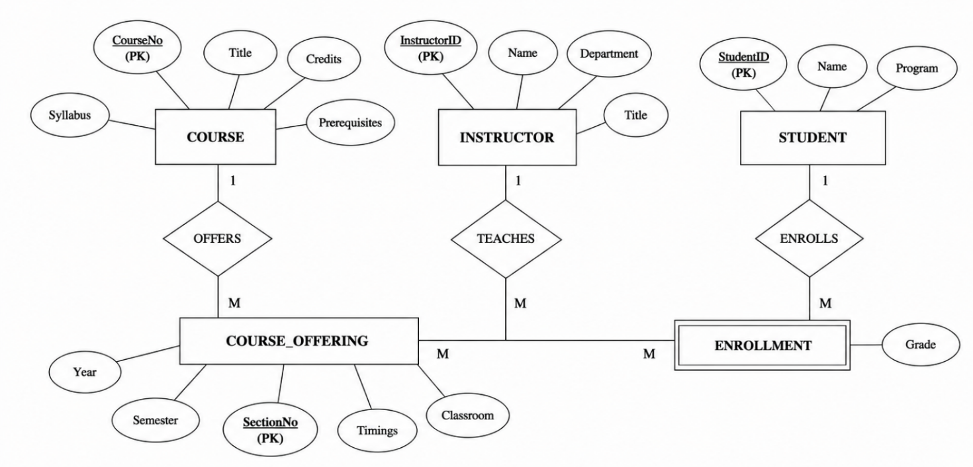4.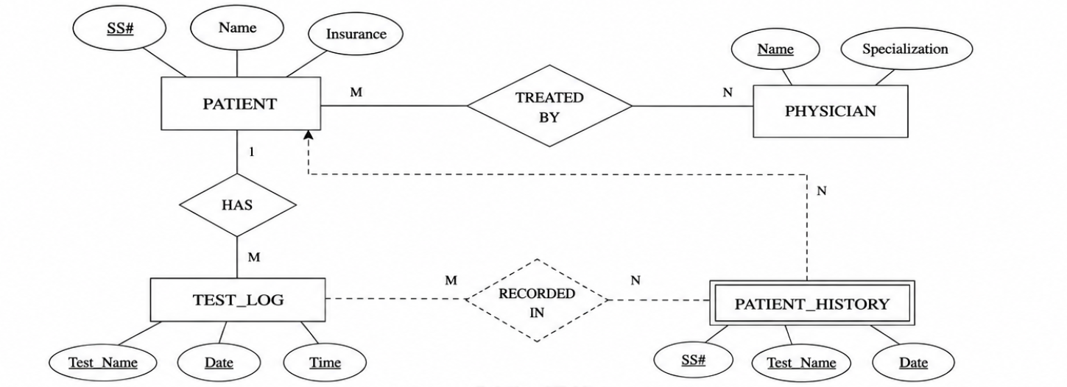

5.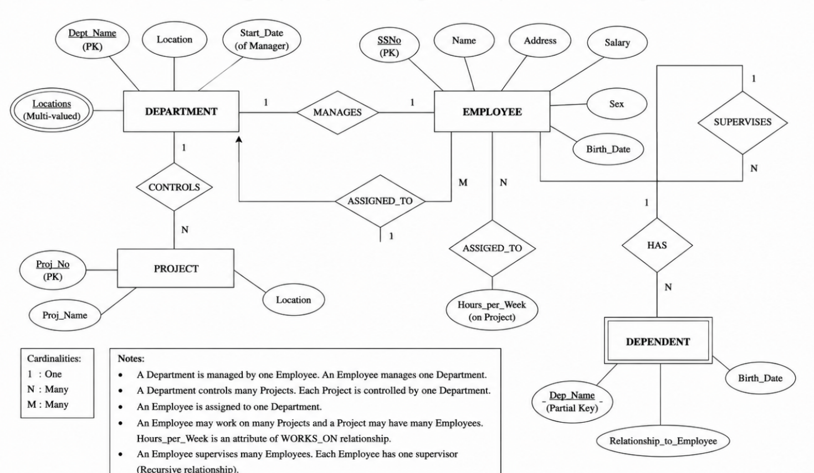

6. Schema
A schema is the overall structure or blueprint of a database. It defines how data is organized, including tables, attributes, relationships, and constraints. A schema changes very rarely.
Example:
STUDENT(Student_ID, Name, Department, Age)

Instance
An instance is the actual data stored in the database at a particular point in time. It changes whenever records are inserted, updated, or deleted.
Example:
Student_ID | Name | Department | Age
101 | Rahul | CSE | 20
102 | Priya | IT | 19

Difference between Schema and Instance
Schema | Instance
Blueprint of the database | Actual data stored in the database
Changes rarely | Changes frequently
Defines structure | Contains current data

Types of Schema
1. Logical Schema
- Defines the logical structure of the database.
- Specifies tables, attributes, relationships, and constraints.
- Independent of physical storage.
2. Physical Schema
- Describes how data is physically stored on disk.
- Includes storage structures, indexing, and file organization.
- Managed mainly by the DBA.
3. View Schema (External Schema)
- Represents the part of the database visible to a particular user.
- Provides security by hiding unnecessary data.
- Different users can have different views.

7.

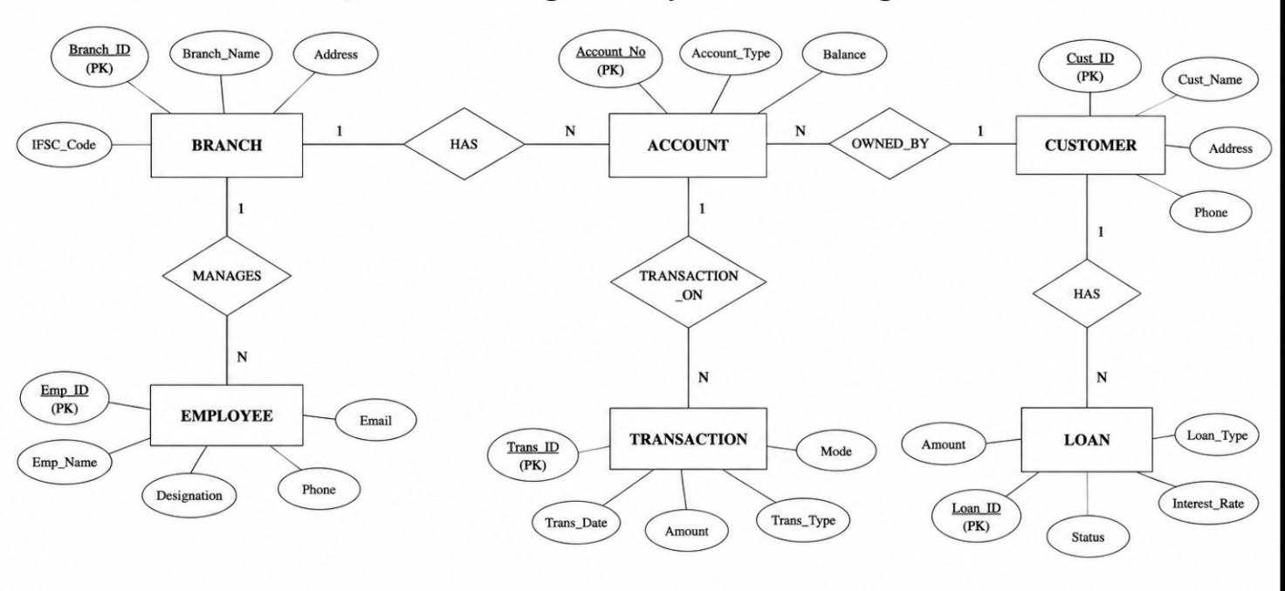
8. Extended Entity Relationship (EER) Model
The Extended Entity Relationship (EER) Model is an extension of the basic ER model. It provides advanced features such as generalization, specialization, inheritance, and aggregation, making it suitable for modeling complex real-world databases.

1. Generalization
- Generalization is the process of combining two or more lower-level entities into a higher-level entity based on their common attributes.
- It follows a bottom-up approach.
- Common attributes are placed in the superclass.
Example:
Car Bike
\ /
\ /
Vehicle

2. Specialization
- Specialization is the process of dividing a higher-level entity into lower-level entities based on distinguishing characteristics.
- It follows a top-down approach.
- Subclasses inherit all attributes of the superclass.
Example:
Employee
/ \
Manager Engineer

3. Aggregation
- Aggregation is used when a relationship itself participates in another relationship.
- It treats a relationship as a higher-level entity.
Example:
Employee ---- Works_On ---- Project
|
Supervised_By
|
Manager

9.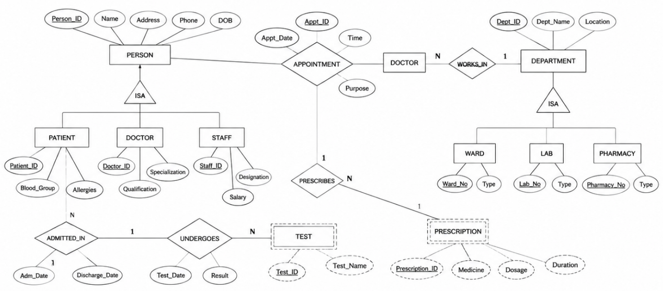

10. Database Administrator (DBA)
A Database Administrator (DBA) is a person responsible for installing, managing, securing, and maintaining a database. The DBA ensures that the database is available, reliable, secure, and performs efficiently.
Responsibilities of a DBA
- Database Installation and Configuration
  - Installs and configures the DBMS software.
- Database Design
  - Creates and maintains database structures, tables, and schemas.
- Security Management
  - Creates user accounts, assigns permissions, and protects data from unauthorized access.
- Backup and Recovery
  - Performs regular backups and restores data in case of system failure.
- Performance Monitoring
  - Monitors database performance and optimizes queries for better speed.
- Data Integrity
  - Ensures data accuracy, consistency, and integrity using constraints and validation.
- Storage Management
  - Manages database storage space and allocates memory efficiently.
- Database Maintenance
  - Updates the database, fixes errors, and applies software patches.
- Disaster Recovery
  - Develops recovery plans to prevent data loss during hardware or software failures.
- User Support
  - Assists users in resolving database-related issues and ensures smooth database operations.
Functions of a DBA
- Maintains database security.
- Ensures high availability of data.
- Improves database performance.
- Performs backup and recovery.
- Maintains data consistency and reliability.

